**DAILY ONLINE ACTIVITIES SUMMARY**

|  |  |  |  |  |  |  |  |  |
| --- | --- | --- | --- | --- | --- | --- | --- | --- |
| **Date:** | **06-06-2020** | | | | | **Name:** | **Ashwini** | |
| **Sem & Sec** | **A** | | | | | **USN:** | **4AL17CS017** | |
| **Online Test Summary** | | | | | | | | |
| **Subject** | | **Python.** | | | | | | |
| **Max. Marks** | | **30** | | **Score** | | | **15** | |
| **Certification Course Summary** | | | | | | | | |
| **Course** | **INTRODUCTION TO ETHICAL HACKING** | | | | | | | |
| **Certificate Provider** | | | Greatlearning  Academy | | **Duration** | | | 6hours |
| **Coding Challenges** | | | | | | | | |
| **Status: Done** | | | | | | | | |
| **Uploaded the report in Github** | | | | | **YES** | | | |
| **If yes Repository name** | | | | | <https://github.com/ashwiniachar/online-report> | | | |
| **Uploaded the report in slack** | | | | | **YES** | | | |

Online Test Details:

Subject:-Python.

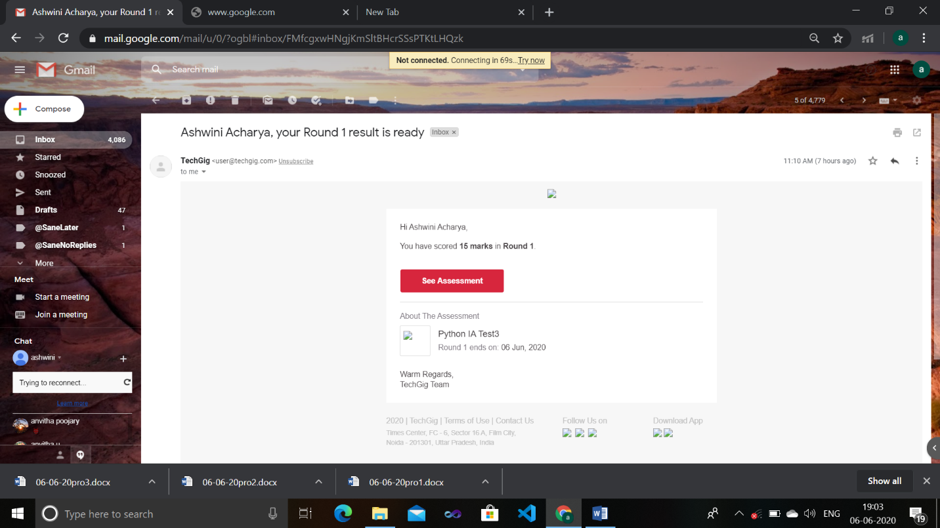CERTIFICATION COURSE:

**Introduction to Full Stack development:**

Today I have studied **Introduction to full stack developmengt:**



1. Write a program in C to rotate an array by N positions.

**Expected Output :**  
**The given array is :** 0 3 6 9 12 14 18 20 22 25 27  
Enter the Position N from where you want to rotate: 4  
From 4th position the values of the array are : 12 14 18 20 22 25 27  
Before 4th position the values of the array are : 0 3 6 9  
After rotating from 4th position the array is:  
12 14 18 20 22 25 27 0 3 6 9

#include <stdio.h>

void shiftArr1Pos(int *arr1, int arrSize)

{

int i, temp;

temp = arr1[0];

for(i = 0; i < arrSize-1; i++)

{

arr1[i] = arr1[i+1];

}

arr1[i] = temp;

}

void arr1Rotate(int *arr1, int arrSize, int rotFrom)

{

int i;

for(i = 0; i < rotFrom; i++)

{

shiftArr1Pos(arr1, arrSize);

}

return;

}

int main()

{

int arr1[] = {0,3,6,9,12,14,18,20,22,25,27};

int ctr = sizeof(arr1)/sizeof(arr1[0]);

int i;

printf("The given array is : ");

for(i = 0; i < ctr; i++)

{

printf("%d ", arr1[i]);

}

printf("\n");

printf("From 4th position the values of the array are : ");

for(i = 4; i < ctr; i++)

{

printf("%d ", arr1[i]);

}

printf("\n");

printf("Before 4th position the values of the array are : ");

for(i = 0; i < 4; i++)

{

printf("%d ", arr1[i]);

}

printf("\n");

arr1Rotate(arr1, ctr, 4);

printf("\nAfter rotating from 4th position the array is: \n");

for(i = 0; i<ctr; i++)

{

printf("%d ", arr1[i]);

}

return 0;

}

**Output:**

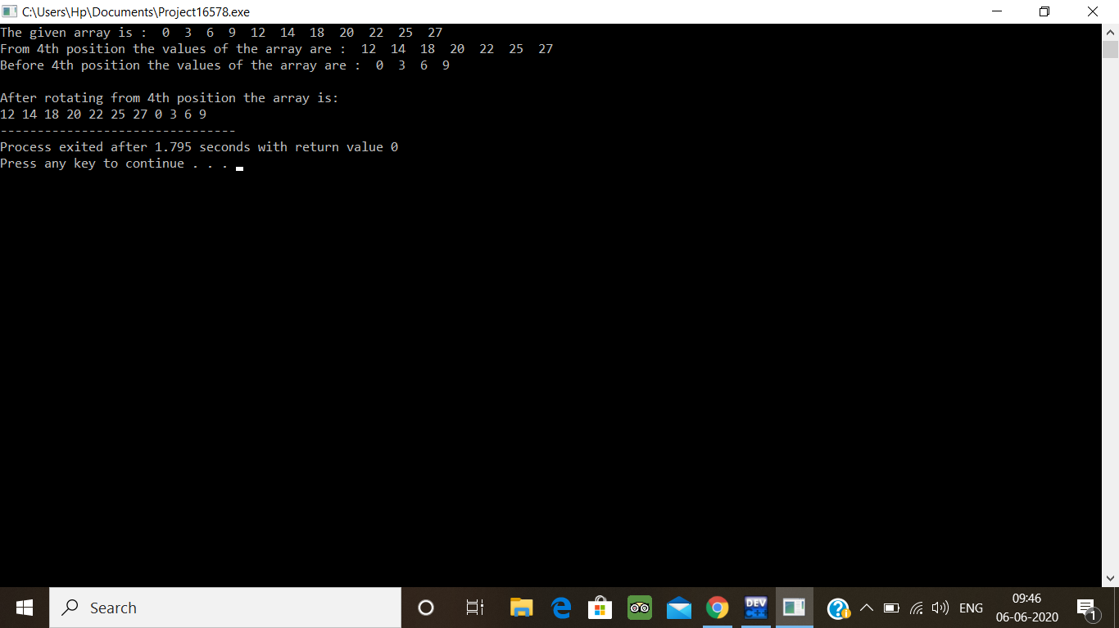

2. Write a Python program to perform Cyclic Redundancy Check

CRC uses Generator Polynomial which is available on both sender and receiver side. An example generator polynomial is of the form like x3 + x + 1. This generator polynomial represents key 1011. Another example is x2 + 1 that represents key 101.  
Data word to be sent - 100100  
Key - 1101 [ Or generator polynomial x3 + x2 + 1]

def xor(a, b):

result = []

for i in range(1, len(b)):

if a[i] == b[i]:

result.append('0')

else:

result.append('1')

return ''.join(result)

def mod2div(divident, divisor):

pick = len(divisor)

tmp = divident[0 : pick]

while pick < len(divident):

if tmp[0] == '1':

tmp = xor(divisor, tmp) + divident[pick]

else:

tmp = xor('0'*pick, tmp) + divident[pick]

pick += 1

if tmp[0] == '1':

tmp = xor(divisor, tmp)

else:

tmp = xor('0'*pick, tmp)

checkword = tmp

def encodeData(data, key):

l_key = len(key)

appended_data = data + '0'*(l_key-1)

remainder = mod2div(appended_data, key)

codeword = data + remainder

print("Remainder : ", remainder)

print("Encoded Data (Data + Remainder) : ",

data = "100100"

key = "1101"

encodeData(data, key)

**output:**

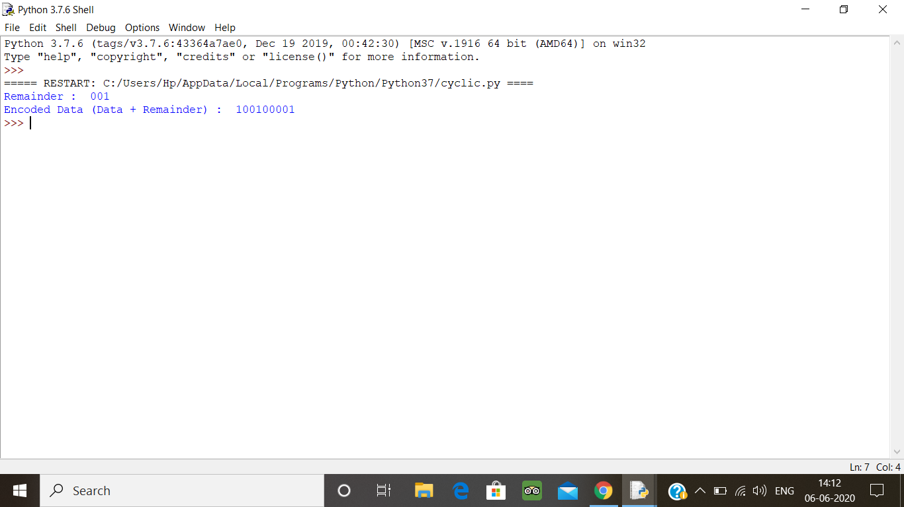

3. Description:  
Write a Python program to count the number of strings, provided string length is 2 or more and the first and last character are same from a given list of strings.  
Eg:  
Input  
list1['hia', 'aba' , '363']  
Output:  
Number of strings with first and last cahracter is same: 2

def match_words(words):

ctr = 0

for word in words:

if len(word) > 1 and word[0] == word[-1]:

ctr += 1

return ctr

print(match_words(['hia', 'aba' , '363']))

**output:**

